**EXP NO: 09**

**DATE: 14-04-24**

**Aim:**

Create a simple cloud software application for Hospital information system for SIMATS Hospital using any Cloud Service Provider to demonstrate SaaS with fields of patient name, age, address, phone, email, Attender name, attender phone, doctor name, diseases, etc.

**Implementation:**

**1. Go to Zoho.com and login/signup**

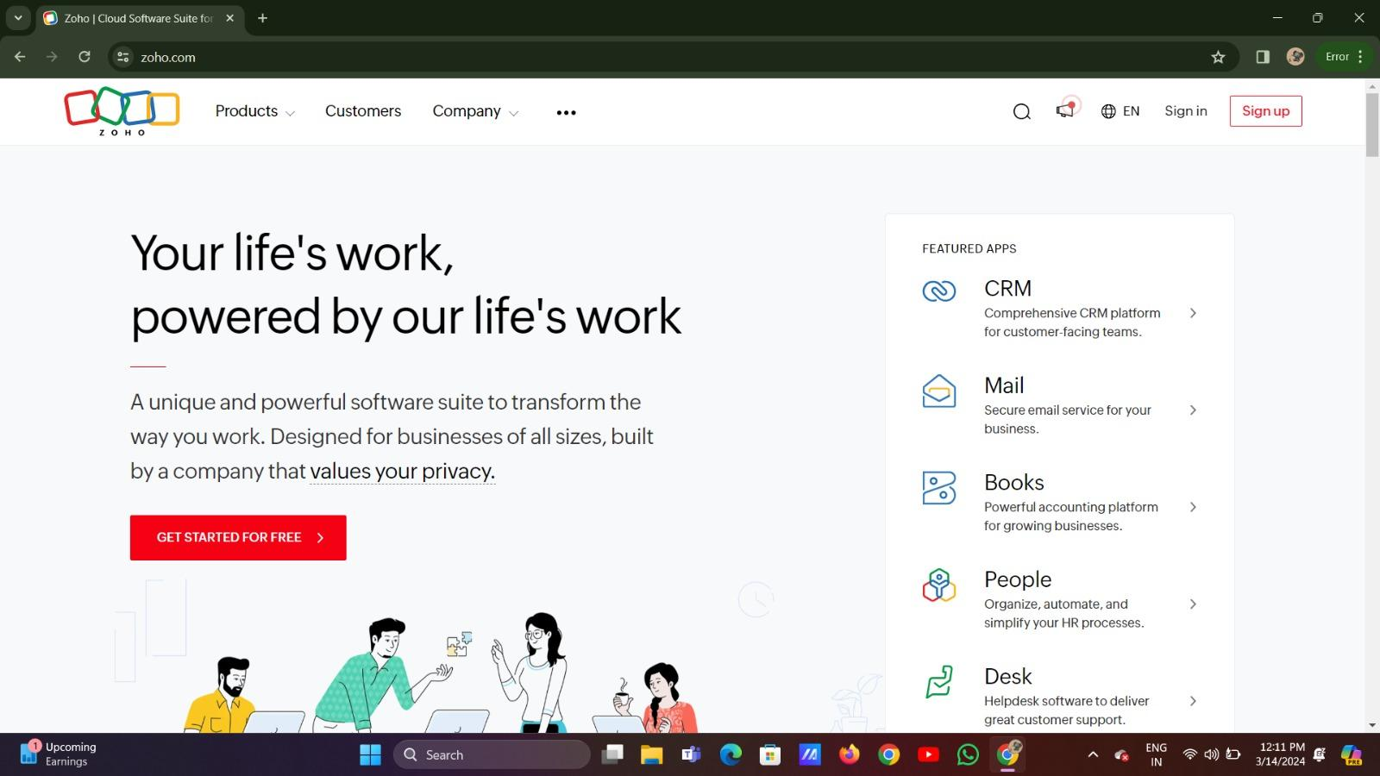

**2. Go to Creator**

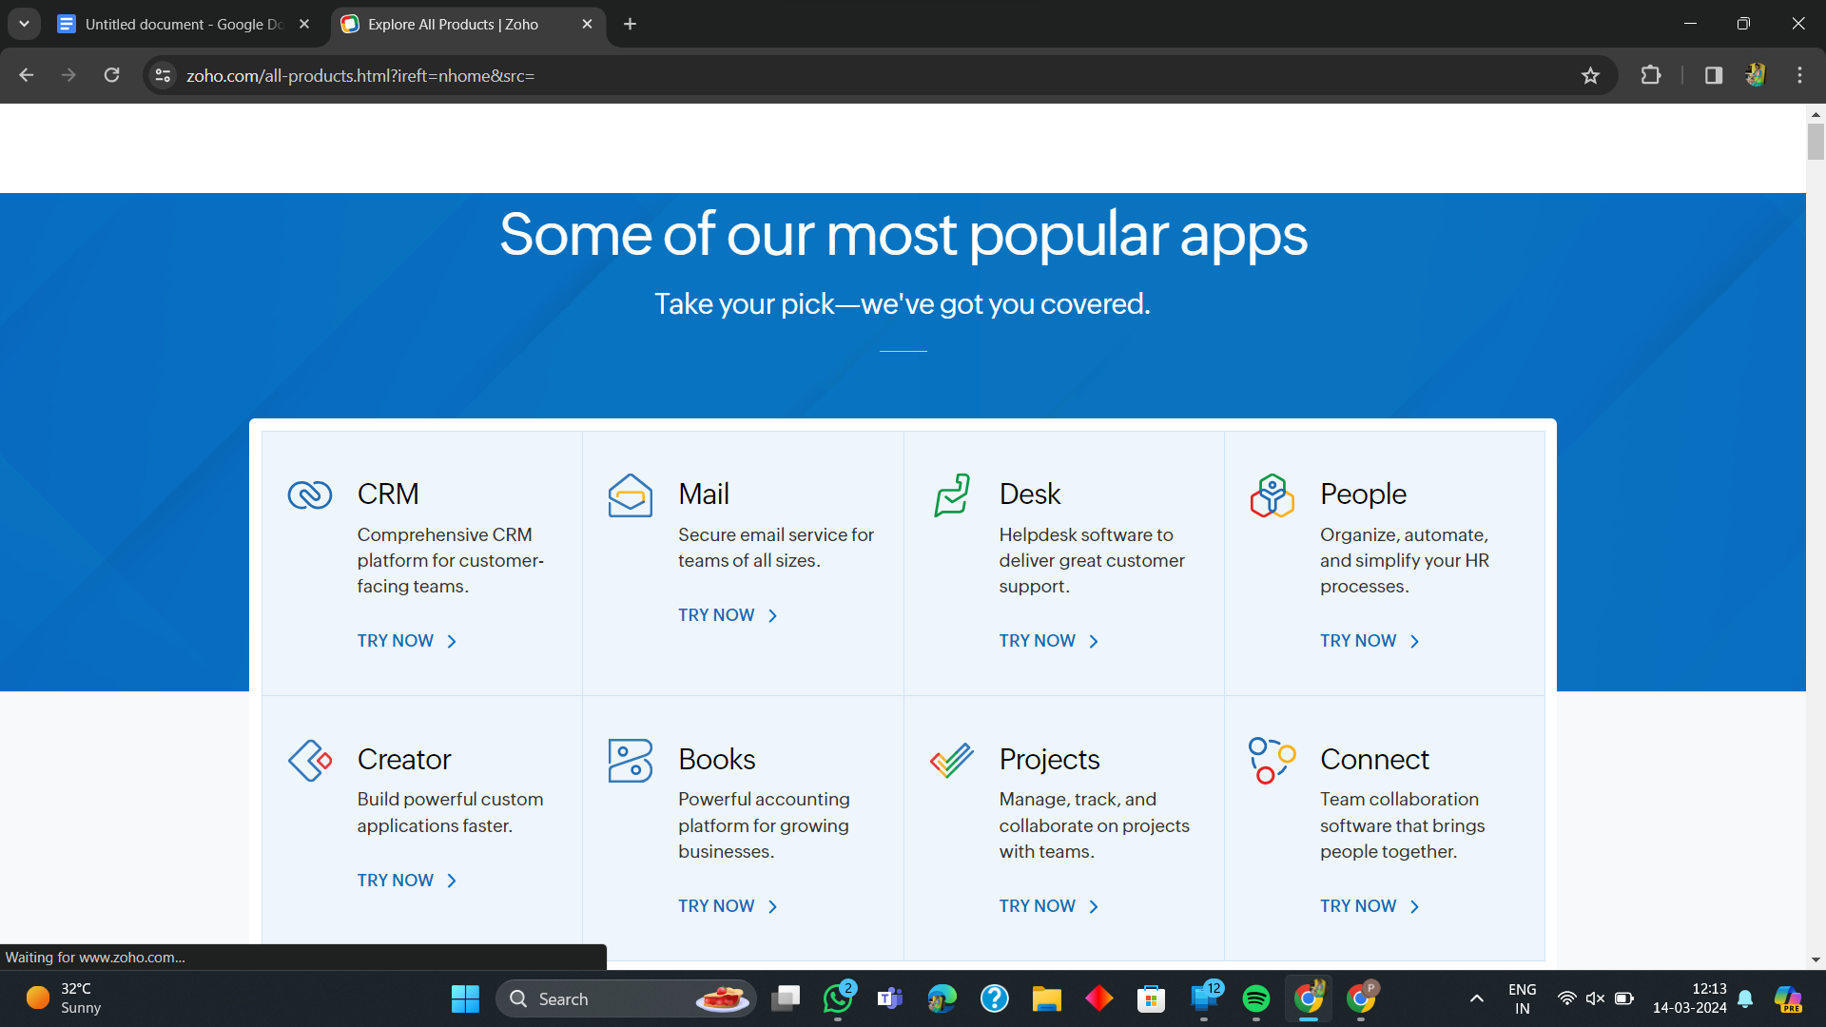

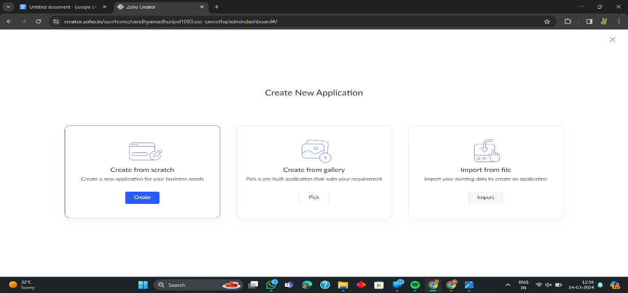**3. Create A New Application**

**4. Given Application Name**

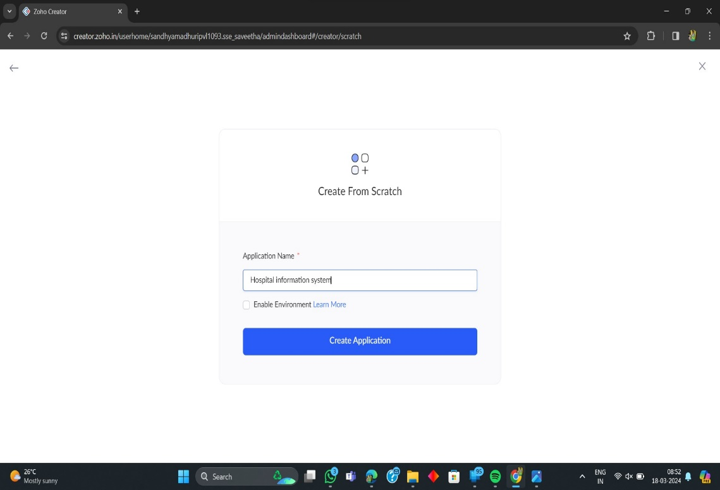

**5. Create New Form**

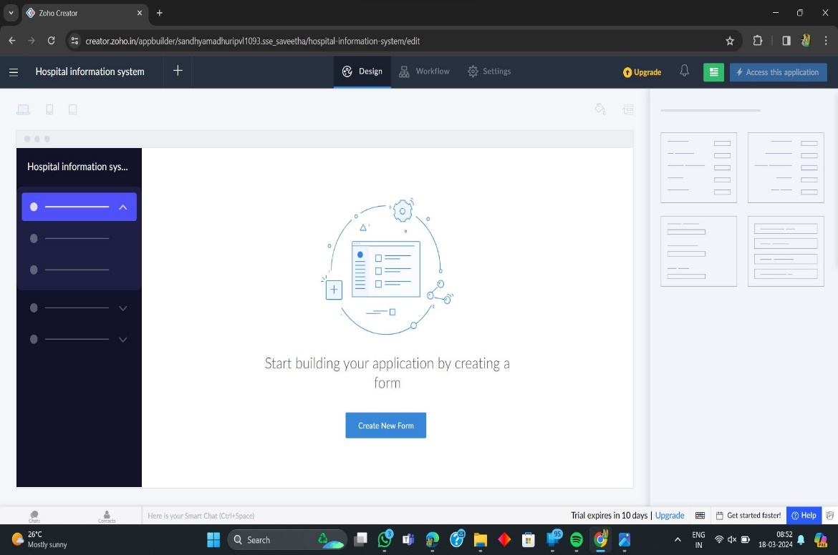

**6. Select Form and Give Name**

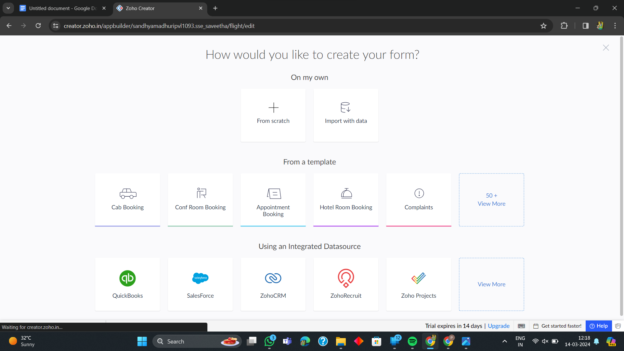

**7. Create from scratch**

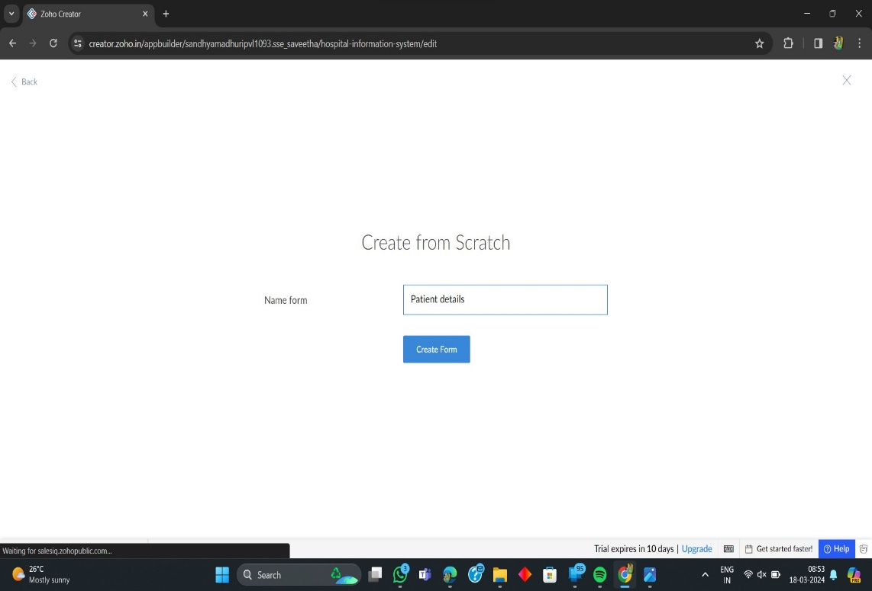

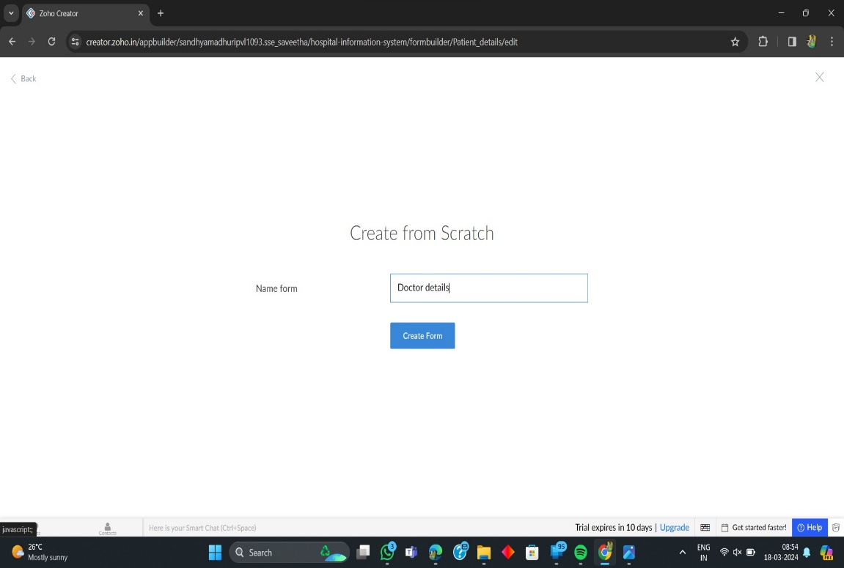

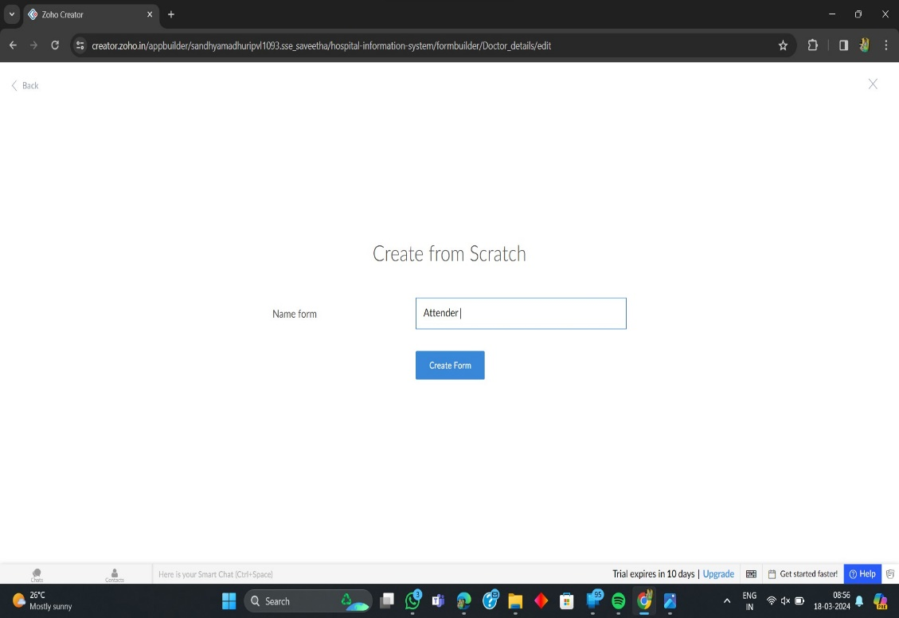

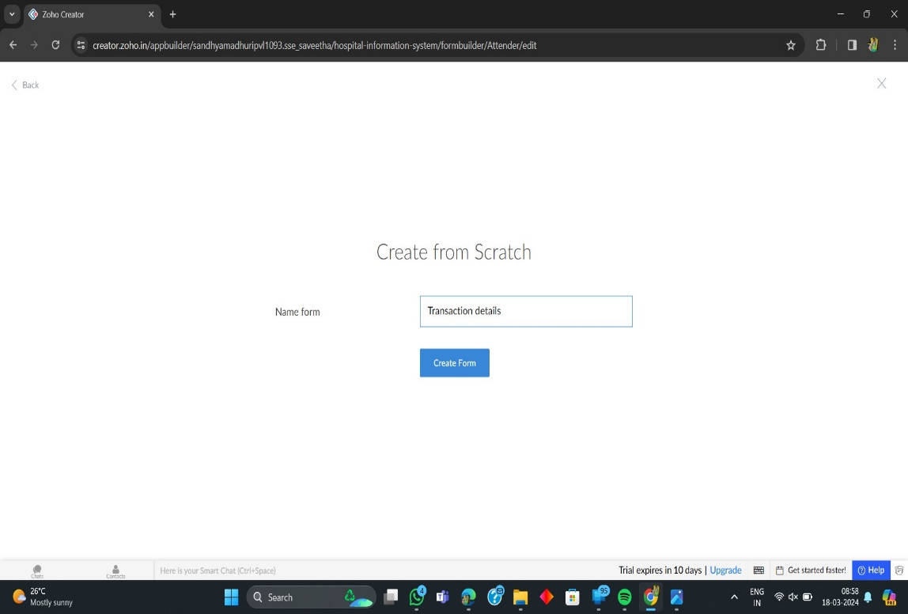

**8. The Software Has been created**

